
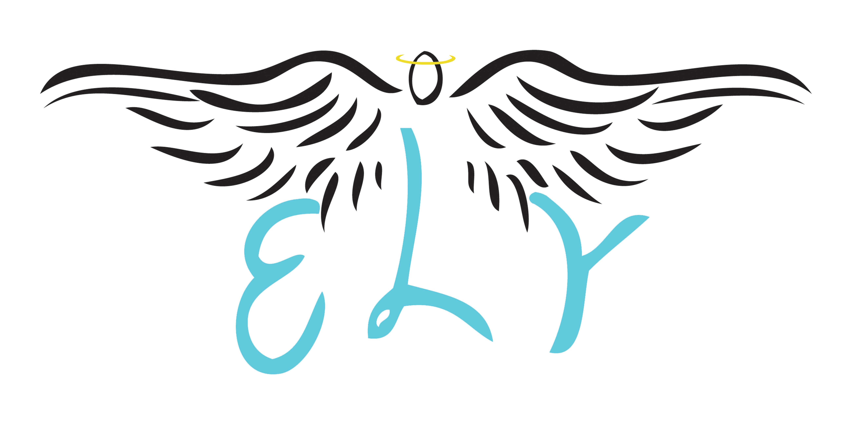

Emma Louise Young

The ELY Memorial Fund
“HUGS from ELY”

We send our deepest sympathy at this time, there are no words to describe the traumatic unexpected loss of losing your child from a road traffic accident. We too have suffered the same loss as yourselves. Arranging a funeral for your loved one will be extremely harrowing, this is why we set up the ELY Memorial Fund offering a condolence gift of £2,000 (subject to meeting criteria) to bereaved parents who lose a son/daughter between the ages 17 to 25 years of age, in particular but not exclusively.

The ELY Memorial Fund is a Registered Charity - No. 1148535, www.ely-memorial-fund.org.uk. We lost our daughter Emma in a road traffic accident on the 30th September 2010. We know this is a traumatic time for the family, but we hope that ELY can help you through your darkest days, so that you can celebrate your Son/Daughter’s life, knowing there is some help to relieve your financial pressures.

Please complete the form below and pass this to your Undertaker. The Trustees will endeavour to help you should you fulfil the criteria to help pay partial costs of the funeral.
………………………………………………………………………………………0000 ………………………………………………………………………………………….
Name of your loved one: …………………………………………………………………………………………………………………………………………………

Names: …………………………………………………………………………………………………………………………………………………………………………….

Address: ………………………………………………………………………………………………………………………………………………………………………….

………………………………………………………………… Tel no: …………………………………………………………………………………………………………

Signatures of Next of Kin/Legal Guardian: …………………………………………………………………………………………………………...

…………………………………………………………………………………………………………………………………………………………………………………………….
……………………………………………………………………………………………………………………………………………………………………………………………………………………………….

List of Charities offering emotional and practical support:-
BRAKE www.brake.co.uk
Compassionate Friends www.compassionatefriends.co.uk
Care for the Family www.careforthefamily.org.uk

QUALIFYING CRITERIA FOR
THE ELY MEMORIAL FUND – FUNERAL PLAN

1. | Is the deceased aged between 17 to 25: D.O.B.

2. | Family resides within the County Boundary of Herefordshire | Yes | No

3. | Was the deceased a driver or passenger travelling in a car? | Yes | No

4. | Has the deceased a Life Insurance Policy? | Yes | No

5. | Family must be Next of Kin or Legal Guardian | Mother:……………………………….
 |  | Father:………………………………..
Other:…………………………………
(please specify)

6. | Both Parents or Legal Guardian : Signatures required
 | Mother: ……………………………………………………………………………
 | Father: …………………………………………………………………………..
Other:
(please specify) ………………………………………………………………….

7. | Special Circumstances:
 | Has the deceased past away within a month of his/her 17th birthday? | Yes | No
 | Has the deceased past away a month after his/her 26th birthday, are not married and live with next of kin/legal guardian? | Yes | No
 | Any other information which may help your application?

Form to be signed by:

Funeral Undertaker: ……………………………………………………..

Next of Kin/Legal Guardian: ……………………………………………

Checked by:-

Director & Vice-Chair of The ELY Memorial Fund:

A. Tyler: ………………………………………………………. G. Young: ……………………………………………..

Date:


Registered Charity No. 1148535
Office: 39 Grandison Rise, Tupsley, Hereford. HR1 1PP
Email: hugs4u@ely-memorial-fund.org.uk
Telephone No: 01432 359152

