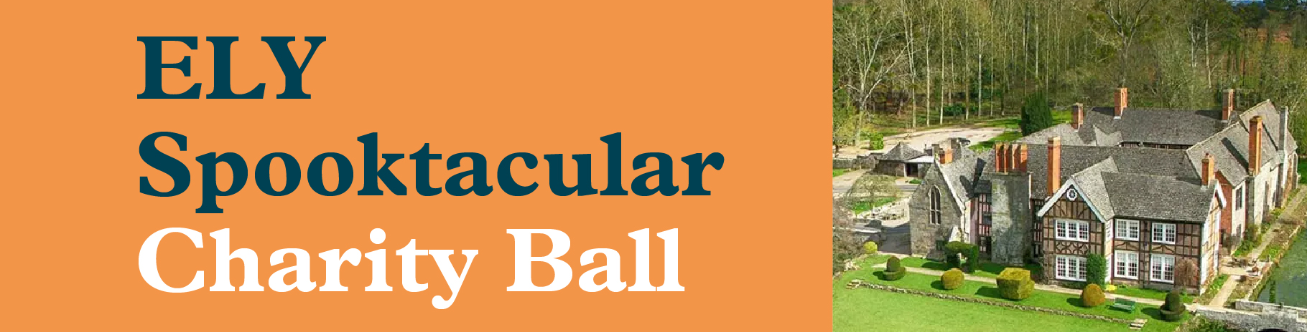

BOOKING FORM
ELY CHARITY BALL
FRIDAY 27 OCTOBER 2023
BRINSOP COURT, HEREFORD
Lead Name: | Mobile/Tel No:
No. of Tickets:
Guest Names:
Dietary requirements: | Please state guest name and requirement:
Deposit: | £25 per person (non-refundable) on booking
Balance due: | 7th October 2023
Payment options: | Cheque made payable to The ELY Memorial Fund  Bacs: Sort Code: 30-80-55 Account Number: 79355060
Return to form: | The ELY Memorial Fund, 3 Avocet Road, Holmer, Hereford HR4 9WA  Or via email: hugs4u@ely-memorial-fund.org.uk

We would be grateful with the help of any raffle donation for the evening.
If you would like to support ELY please let us know.
We look forward to celebrating our evening with you on the 27 October 2023.
Ange Tyler
Charity Manager
07877591583

