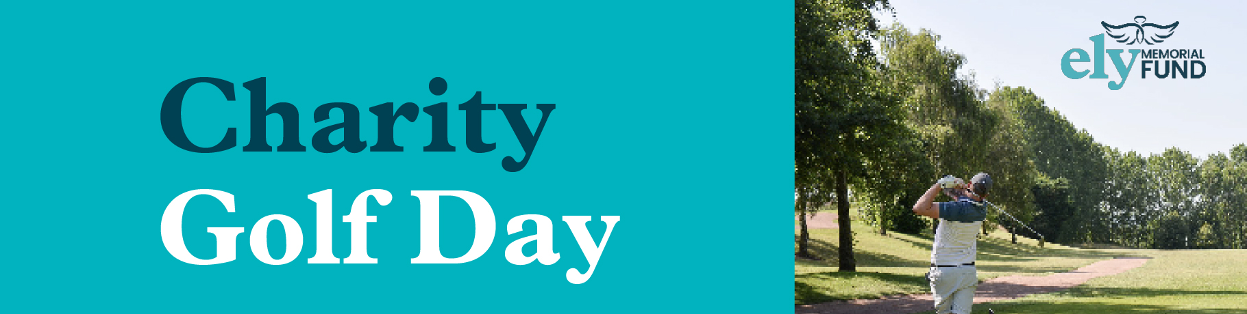

Registered Charity No: 1148535

ELY Charity Golf Day 2023
Burghill Valley Golf Club on Saturday 15th July 2023
Entry costs £150 for any four ball team and includes
bacon roll, coffee, golf and a 2 course meal
There will also be team trophies and a raffle!
Team Name | Individual Names | Email address of Team Captain | Preferred Tee Time Between  8.45am - 1.30pm | Handicap

Please complete the form and return with the entry fee to
Ange Tyler, 3 Avocet Road, Holmer, Hereford, HR4 9WA by 30th June 2023.
Cheque made payable to The ELY Memorial Fund
Bacs: Sort Code: 30-80-55 Account Number: 79355060
Email: hugs4u@ely-memorial-fund.org.uk

