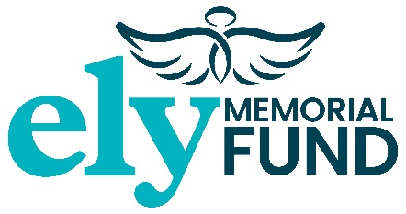
THE ELY MEMORIAL FUND CHARITY
YOUNG DRIVER EXPERIENCE
EVENT TERMS AND CONDITIONS

The Terms and Conditions detailed below apply to all students taking part in the Young Driver Experience being held on 26th, 27th, 28th, 31st July & 1st August 2023. Completion of an entry form and payment for entry acknowledges acceptance of these Terms and Conditions.
- The minimum age of registration is 14 years to 17 years of age. Your son/daughter will be allowed to attend with parental or legal guardian consent who must sign the Event Registration form on their behalf.

- Appropriate clothing and footwear for the event is required, such as pumps/shoes, jeans, tshirts/hoodies/jacket. Inclement weather outdoor clothing is essential.

- As parent or legal guardian you agree on completion of entry form that your son/daughter are fit and capable to attend the Young Driver Experience.

- The ELY Memorial Fund requests that your son/daughter adhere to instructions for health & safety purposes during the event.

- At the discretion of the ELY Memorial Fund should any action of the student deem to be unacceptable, the Charity reserves the right to contact the parent/legal guardian and ask for their son/daughter to be collected from the event.

- Public Liability Insurance is provided for the event and driving with Go-Driving. DBS checks are also in place for all partners delivering the event.

- We ask that you grant the right of permission for the ELY Memorial Fund to publish any photographs/video of the Young Driving Experience and waives any right to any compensation for appearing in such content.

- The ELY Memorial Fund respects your privacy and will not share your personal details. We will take all steps necessary to ensure that your information is treated securely, in accordance with the General Date Protection Regulations (GDPR) May 2018. Please tick the box if you wish the ELY Memorial Fund to retain your information to keep you up to date with the charities fundraising events without restriction for the next two years.

- Please tick the relevant box by email □ or by telephone □ details: ……………………………………………………..

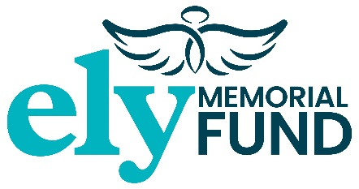
YOUNG DRIVER EXPERIENCE
HEREFORDSHIRE & LUDLOW COLLEGE, FOLLY LANE, HEREFORD HR1 1LS
PARENTAL CONSENT
TO BE SIGNED BY PARENT OR GUARDIAN
FOR STUDENTS BETWEEN THE AGES 14-17
DATE TO ATTEND ……………………………………………… (please insert date)

I (Name & Address) :…………………………………………………………………………………………………………………………………………..
…………………………………………………………………………………………………………………………………………………………………………..
Being the parent (or guardian) of: …………………………………………………………………………………………………………………….
Who was born on:……………………………………………………………………………………………………………………………………………..
HEREBY AGREE to your son/daughter participating in the above event promoted for an on behalf of the ELY Memorial Fund under its events Terms & Conditions and DECLARE as follows:-
- I understand and agree that my son/daughter participates in the said event for the date mentioned above and is willing to undertake the activities of driving within a controlled environment with Go-Driving Instructors, learn basic car maintenance, basic roadside first aid and road safety workshops.
- I am satisfied that my son/daughter is sufficiently responsible to participate and assume full responsibility for their own actions during the event.
- Your son’s/daughter’s information will only be used for this event and not used for any other purposes or shared with any other organisations.
- I consent to my son’s/daughter’s personal data to be used for this event.

Signed: …………………………………………………………………………………… Dated: ………………………………………………………….

Angela Tyler
Charity Manager
The ELY Memorial Fund
Mobile: 07877591583

Please sign & date this page and return.

REFRESHMENTS AND LUNCH PROVIDED -
It will not be necessary for your Son/Daughter to bring refreshments or lunch this will be provided on the day. However, if they want to bring their own water that is acceptable.
Please state whether they have any allergies:-
…………………………………………………………………………………………………………………………………………………………
…………………………………………………………………………………………………………………………………………………………

MEDICATION:
Please do let us know if your Son/Daughter takes any medication that may affect their ability to drive and participate in the workshops.
…………………………………………………………………………………………………………………………………………………………
…………………………………………………………………………………………………………………………………………………………

………………………………………………………………………………………………………………………………………………………………………………….

Please complete and return this page.

Name: Date attending YDE:
Payment is due by the 10th July 2023
Fee of £25.00
BACs: The ELY Memorial Fund, Lloyds Bank
Sort Code: 30-80-55 Account No: 79355060
Cheque to:- “THE ELY MEMORIAL FUND”,
3 Avocet Road, Holmer, Hereford HR4 9WA
Email: hugs4u@ely-memorial-fund.org.uk
Cash payment can be delivered to the above address.

