REGISTRATION FORM

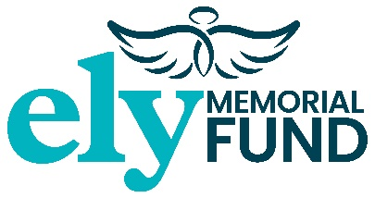  Registered Charity No. 1148535  www.ely-memorial-fund.org.uk | IN AID OF  The ELY Memorial Fund | Emma Louise Young

Finale ELY Cycle Challenge
Sunday 2nd July 2023 at Westfields Football Club,
Widemarsh Common Hereford HR4 9NA
32 miles (£10) - 46 miles (£15) - 71 miles (£20) - (circle your entry)

Name:
Address:
Email Address:
Mobile No:
Next of Kin:
Address & Contact No’s:
Do you have any medical problems that I should be aware of?
Agree to retain only your information (not next of kin) for legitimate interest – please see below YES □ NO □
Please return form to: The ELY Memorial Fund, 3 Avocet Road, Holmer Hereford HR4 9WA
Payment details: Lloyds Bank, Sort Code: 30-80-55 Account: 79355060
Gift Aid: YES □ NO □

Taking part in the ELY Cycle Challenge 2023 is at the cyclists own risk and by completing the registration form agree to the Terms & Conditions for the Event (see website www.ely-memorial-fund.org.uk). The ELY Memorial Fund Charity recommends that each cyclist obtains their own personal insurance cover. We ask that each participant allows and grant the right of permission for the ELY Memorial Fund to publish any photographs/video of the cycling event and that you waive any right to any compensation for appearing in such content. The ELY Memorial Fund respects your privacy and will not share your personal details. We will take all steps necessary to ensure that your information is treated securely, in accordance with the General Data Protection Regulations (GDPR) May 2018. If you wish the ELY Memorial Fund to retain your information to keep you up to date with the charities fundraising events by way of email or telephone please tick the relevant box above.

